Poll Web

Functionalities:

As in the specification written, we have three types of users.

* administrator
* manager
* user (simple participant)

Administrator:

This type of user is preregistered to the system (email: [admin@admin.com](mailto:admin@admin.com) password: admin). The administrator can see all the managers and all the public polls. He is also the one, who can registrate all the managers. He must set the new manager’s email address and password.

Manager:

The manager’s main role is that he can create polls. He must set the poll title, opening text and closing text. These are required to a poll. He is able to add questions. If he sets the poll to required, he going to be redirected to another page, where he have to add the users email addresses. (All the users’ email, whom he wants to add. It has to be divided by ‘,’ character.) After this, he could not modify the poll. He can also visit all his own polls and the public polls too. He can participate any of these. The manager can also see the users’ answers.

User:

The user’s only role is to participate the polls. A user is created when the manager add an email address to a poll. The user’s password is generated and one email address can be added more times but it will have different assigned poll. Moreover the user can participate any public poll even if he logged in before.

For example: Manager1 make Poll1 and add the [user@gmail.com](mailto:user@gmail.com) email address to it. Also, he create Poll2 and add the [user@gmail.com](mailto:user@gmail.com) email address. If the owner of this email address use his first password, he can participate the Poll1. In the same time, if he use his second password, he can participate the Poll2.

The other entities:

Poll:

Every poll has a title, open text, close text, questions, owner and it can be reserved or not. All these are required. The title, open text and close text are obvious after their name. There could be one or more questions. The owner of the poll is a manager who created it. If the poll is not reserved, then everyone could participate it. If it reserved, then only the users who were registered by the owner could participate.

Question:

Each question have:

* text: the actual question
* type
  + short text
  + long text
  + number
  + date
  + single choice
  + multiple choice
* position: the position in the poll (first, second…)
* note: a note for the user, it could be some extra information or some supplement for the question
* answer: only for single and multiple choice
* mandatory or not: the participant have to answer it or not

Answers:

It is an entity for saving the results of answered poll.  
Each answer has userID (ID of the user who answered), pollID (ID of the answered poll) and csv file with answers themselves. In this file are stored only name of questions and user’s answer on it.

Screenshots of the most important pages:

Home page

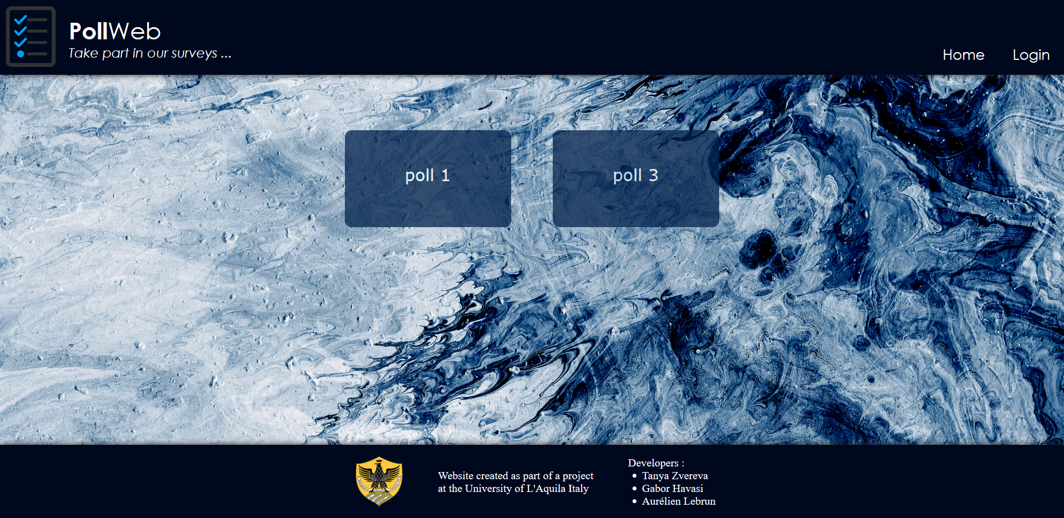

Administrator page

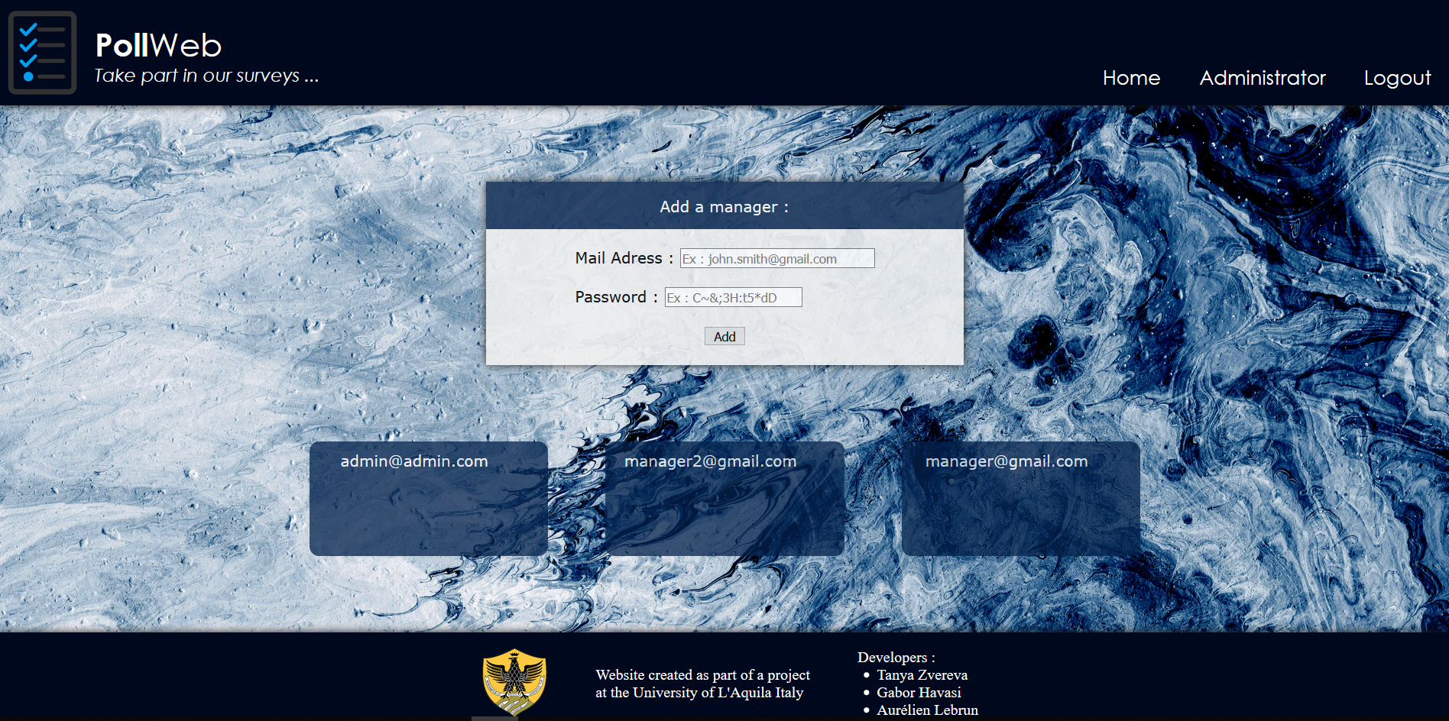

Question page

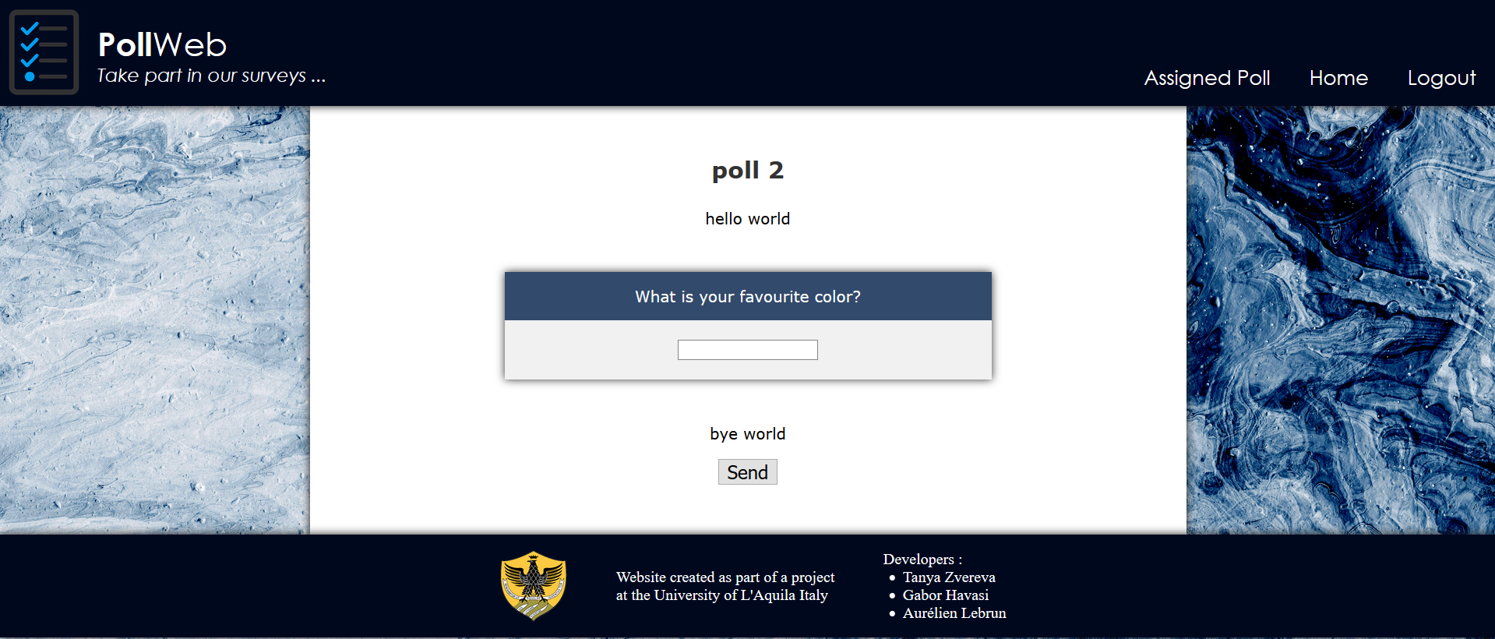

Diagram of the site structure:

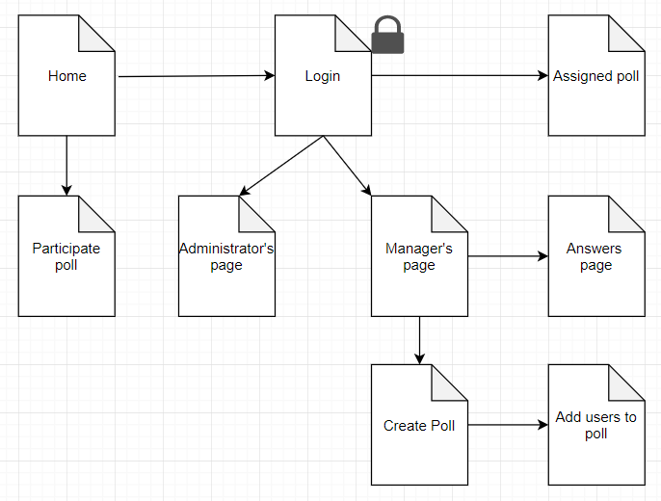

Relation schema of the database: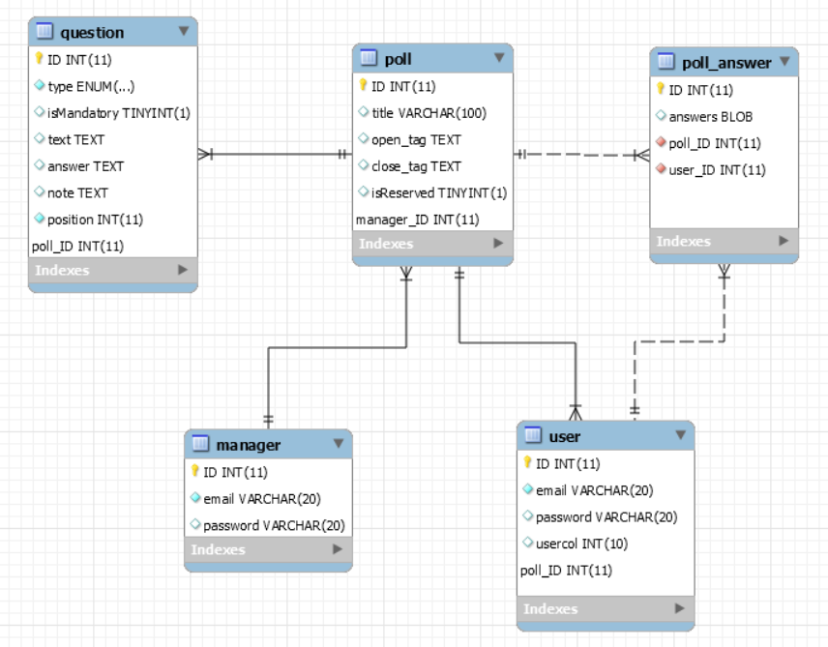

Analytical description:

Without login:

A person without login can access the home page, where he can see all the public polls. These are rendered from the database every time, when the page is refreshed. He can open a poll by clicking on it. In this moment he will be redirected to the poll’s page. He will see the poll title, all the poll details and the questions. This is all dynamically created. By clicking on the “send” button, answers of the poll are recorded to the file and saved to the database table poll_answer, and the user is redirected to the home page. Another option is to login. This button redirect to the login page. This is static.

As a user:

The user have to log in first. The user can do everything, what a person can without logging in. The user has also an extra button in the header. It is available only, if the user has assigned poll which he has not filled yet. By clicking on this button, he will be redirected to this poll.

As a manager:

A manager also can do as much as a person without login plus some extra. If someone logs in as a manager, there shows up a new button in the header. With this, the manager can visit his page. Here he can see all his polls, a button for answers and also a button to add a new one. These are loaded from the database every time, when he refresh the page.

The add button goes to the poll creation page. On this page he can set the poll’s details and add questions. These page is mostly dynamic. The server gets all the details, creates the poll and saves it to the database. If the poll is reserved, he will be redirected to add user page before home page. At the static add user page he have to enter all the email addresses which he wants to add to the poll.

With answer button, the manager is redirected to the page with information about answered polls and users who answered it.

As the administrator:

The administrator also can do as much as a person without login plus he has access to the administrator page. Here, he can see all the existing managers. These are rendered from database. Moreover he can create new managers, with entering a new email address and a password. Clicking on the “add” button the new manager immediately appears in the administrator page.